|  |  |  |  |
| --- | --- | --- | --- |
| Lab No. | Lab Manual | Week | Marks |
| 5 | JavaScript Event Handling Program  CheckBox  Button  TextField  ChomboBox  List | Week 5 | 10 |

**LAB-5**

**Expected OUTPUT**

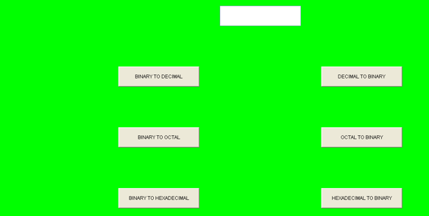

Perform the Event With Button

Note:- One can also perform event with checkbox, radio, List, Choice (select)